

Top Skills

Time management, Producing high-quality work, Motivating self and teams, Engagement habits of effective managers, Managing difficult clients, IT Security & Compliance, IoT, Cloud, Virtualization- Azur/ AWS/ XEN/ Vmware/KVM, Consulting, Application Development, Lecturing, Vendor Management, ITIL, Networking, Data-Centre, SAP, Steganography, OWASP, VAS. Digital Automation.

Languages

English (Native or Bilingual)

Hindi (Native or Bilingual)

Tamil (Native or Bilingual)

Telugu (Native or Bilingual)

Certifications

1. SAP - Introduction to SUSE Linux Enterprise Server (SLES)
2. SAP- Migrating Your Business Data to SAP S/4HANA – New Implementation Scenario
3. The Internet of Things (IoT) with SAP
4. Business Process Automation in SAP S/4HANA with SAP Intelligent RPA
5. Tata – PLC
6. Tata – Machine Lanugage
7. Tata – Industry 4.0
8. (CISM and CEH Certification in progress, about to take exam)
9. Prince 2 Practitioner
10. PMP (Trained)
11. Cisco Certified Network Associate (CCNA) Cisco USA
12. Sun Certified Network Administrator (SCNA) Sun Education, USA
13. Sun Certified System Administrator (SCSA) Sun Education, USA
14. ITIL Certified
15. General Data Protection Regulation (GDPR)
16. Certified Net-ware Administrator (CNA) Novell Education, USA
17. Certified Net-ware Engineer (CNE) Novell Education, USA
18. Sun Certified Enterprise System Administrator Training
19. Sun Education, Singapore
20. Characteristics of the Successful Entrepreneur
21. SUSE Linux Enterprise Server (SLES), Novell Academy SUSE Linux Stream Training, Singapore
22. Certified Information System Security Professional (Trained CISSP)
23. Web Page Design Using HTML 5 and CSS

Contact

+91 87626 60459 (Mobile)

[gkarvindr@gmail.com](mailto:gkarvindr@gmail.com)

[www.linkedin.com/in/gkarvindr](https://www.linkedin.com/in/gkarvindr?jobid=1234&lipi=urn%3Ali%3Apage%3Ad_jobs_easyapply_pdfgenresume%3BKcW3v3dyTtKjTgSQvF7nUw%3D%3D&licu=urn%3Ali%3Acontrol%3Ad_jobs_easyapply_pdfgenresume-v02_profile)

[(LinkedIn)](https://www.linkedin.com/in/gkarvindr?jobid=1234&lipi=urn%3Ali%3Apage%3Ad_jobs_easyapply_pdfgenresume%3BKcW3v3dyTtKjTgSQvF7nUw%3D%3D&licu=urn%3Ali%3Acontrol%3Ad_jobs_easyapply_pdfgenresume-v02_profile)

[it-infratech.in (Company)](http://it-infratech.in/)

[it-infratech.in/consulting (Personal)](http://it-infratech.in/consulting)

Last Updated:

Thu 22 July 2021

Arvind GK

For strategic, productive and profitable solutions and operations.

Looking for *coming* back to *regular managerial role* from consulting.

Bengaluru, Karnataka, India

## Summary

I am with Information Technology from punch-card days with 23+ year of experience with strong temperament to absorb a lot of organizational stress, learn the act of balancing and deal with governance unperturbed, working with clients on strategy, software development, planning and problem solving, and helps clients develop business skills and knowledge. These topics range from designing a business model or marketing plan, to determining which marketing techniques to use and how to use them. I often help clients learn how to plan and implement projects. As small business consultant gives advice, teaches skills, and brainstorms with the client to produce practical results and enhance strategic thinking.

Effectively manage and exploit information through IT, a key factor to business prosperity and create indispensable means to achieving aggressive goals.

Collaborative decision-making between business and IT professionals.

Worked n Application and Infrastructures, developed skills from 1997, first minor setup was Southern shipping corporation, were I laid the first ethernet cable to form a simple server room, then did for Anubhav foundation, then work in DC for media industry , Measat, indovision, foxTV. In India I worked with Citibank handling all Asia pacific DC support, build two full data center, in Madurai and Chennai, build server rooms for Dhamman Steels, Hospet Steels, Natesan Syncrone, Orchid Pharma, Spectrasoft, TVSi, maintained TVS Fasteners DC, TVS Tyres DC.

In application from starting SAP B1 deploying at Spectasoft for various clients worked with SAP for testing to get SAP certification on B1. Interface support for PLC to SAP via Oracle. Support of Spectalab(.net oracle based) tool interface to SAP, via zprogram upload. Weighbride Lorry Image capturing and inteface to image storage and SAP interface. Network leaseline for SAP to HO etc. SAP DR implementation for TVS Tyres, Handing Basis/ Abap team. Some full implementaion site, Natesan Syncrocone, TVS Tyres, Orchid Pharm SAP Support etc.

Increase profits by utilising ICT/IoT frameworks and reduce costs by setting up checks and planning.Some Clients: Futurisk, Natesan Syncrocone, IT-Tech, Hospet Steels, Tevatel, Cornerstone, Friday Solutions, The IT Man, AAA Engineering Collage, National Institute of Wind Energy, BKRISE.

**Proficiency**:

|  |  |
| --- | --- |
| IT Consulting, Strategies  IT Security, Ethical Hacking.  Compliance, OWASP etc.  Defence In Depth.  Steganography.  IoT implementation.  Network Security.  Business advancement.  Software Development.  Make a Road Map for IT in connection to you Business. | System Design and Planning, Security Solutions.  Fittings Solutions.  HW/SW Procurement.  Data-centre Build.  Remote Access Solution.  Backup and Recovery Solutions.  Preparing Service Contracts.  Portals.  Mobile Apps.  Training. |

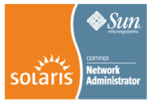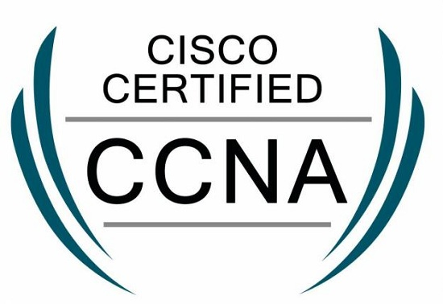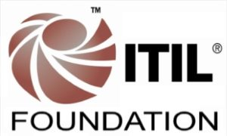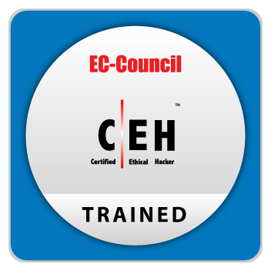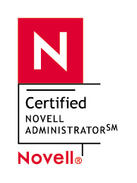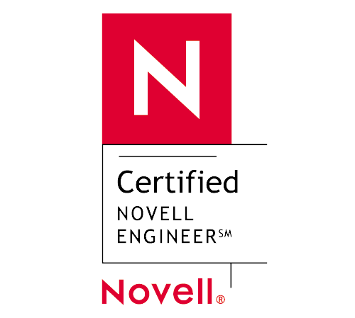

Education

B. Sc,: University of Madras ·

Diploma,:Business Management & Entrepreneurship ·

National Institute of Information Technology:

Honours in System Management, Computers ·

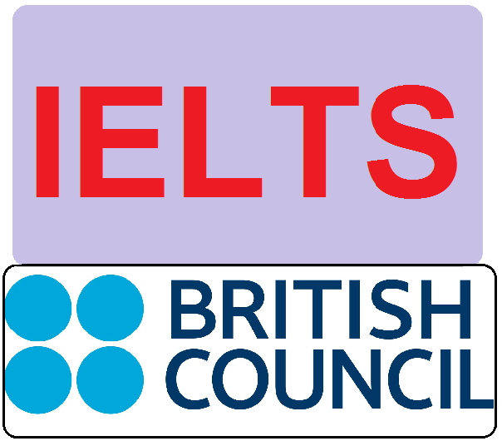

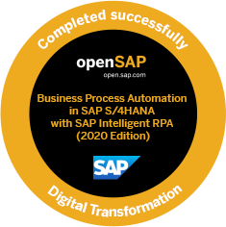

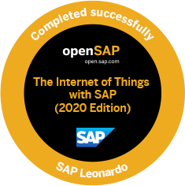

#### Github:

<https://github.com/gkArvindr>

#### Article:

Feb 2020 – OPEN SOURCE For You

<https://opensourceforu.com/2020/02/backing-up-vm-files-with-borg/>

<https://www.linkedin.com/pulse/data-diode-cyber-security-measure-arvind-gk>

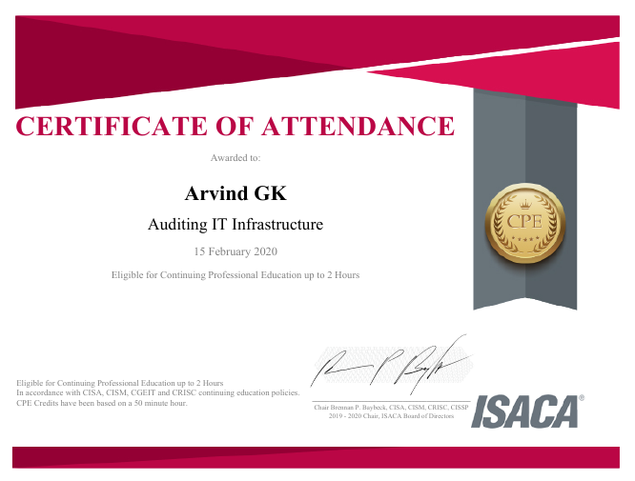

## Experience

### IT Infrastructure Technology Solutions

Independent Information Technology Specialist

2013 – Present

Bangalore Area, India.

With a unique, exciting and inspiring narrative, I know how to harness the power of human curiosity—and about the importance of fostering a culture of collaborative innovation. I represent a new breed of engineer, with insights that make science, technology and Human accessible and prove that we can significantly expand our boundaries.

I began my consulting with vision of a comprehensive end to end IT needs, covering IT Infrastructure, ERP, Application improvement, IT Training, Private cloud or a hybrid environment and so forth. I have made a constant effort to keep myself in the race by upgrading my skill, certification is proven way to show the commitment to the vision.

Have helped organization to settle on the best technology choices for business, and boost the rate of profitability in present and future needs.

I'll work with you to comprehend your business – will get to grasps with your current circumstance, comprehend your arrangements for the future, and afterwards I'll help you get there as many have achieved using my consulting.

With 20 years of strong demonstrated experience, I offer my premium administrations. Kindly reach me to experience the potential advantages.

***Recent Projects :***

**SAP migration**

SAP server migration from in-house to data-centre.

**SAP HANA.**

Base planning for HANA implementation, sizing of HW, redesigning of Server room and network, power. Design of Vehicle Details and tracking inside and out the factory.

### **IT Management , Operations technical advisor for companies.**

Mentoring staff for best practises, Implemented System Monitoring, Ticketing tool (ITIL), Enhanced Security, Finger Print and Face recogniser system implemented for canteen and employee labour attendance system, Anti theft measures, working with Industrial IR team with technical assistance. With user-friendly application and mobile-friendly access with all security features incorporated. Weighbridge integration to ERP, payroll automation, camera integration for weighbridge. Oracle forms based application development and integration to factory automation.

**Backup Product Development.**

Developing a Backup product, that can archive, encrypt work with cloud and local storage. The product will be cost effective in terms of cost, resource utilization, no limitation on the size of files, can back-up live VMs, work on Mac, Linux, Windows.

**Government of India.**

*Geo Tagging Portal*

Windmills tracking in India, capture of production data and data analytics.

“Responsive design”, “mobile-friendly” & “intuitive experience” for portal and mobile application, with security measures.

**Insurance Domain.**

IT Security Policy Design, Development and Implementation**.**

## Service Experience

**AGM IT- Hospet Steel Limited, Hospet Karnataka**

Nov 2018 to Aug 2019 (Assignment )

**IT Infrastructure , SAP Basis , HANA, Payroll, asset management , ABAP Team Handling**

SAP migration

SAP server migration from in-house to data-centre.

SAP HANA.

Base planning for HANA implementation, sizing of HW, redesigning of Server room and network, power. Design of Vehicle Details and tracking inside and out the factory.

Weight Bridge automation, SMS automation (Spectra Equipment )

IP Camera, Face reader etc security measures.

### TVSi – GM IT

December 2010 – June 2013

Responsible for Groups IT,

1. SBU management, people and process.
2. Support business for Group and external customers.(Mittal steels)
3. Handling more than 60 direct employees and more than 100 contract employees.
4. Build State of the Art Data-centre’s from scratch.
5. Brought in first hosting customer in Data centre’s
6. First to implement IPV6 in India.
7. Design of the New office infrastructure, implemented CCTV, Bio metric security system
8. SAP Basis support Head
9. Revamping IT, Enabled Cloud environment, Enabled Hosting Service
10. Revamping IT at Group companies
11. Built State-of-the-art DC at Madurai
12. Designing and Building the second DC at Chennai
13. Cost saving of efforts, Awarded for Cost saving efforts
14. Re Implementation of SAP Servers at 2 major places.
15. DR enabled for companies.
16. Designing of Network connectivity for more than 50 location

### Spectrasoft Technologies

Head IT

August 2007 – January 2010

SAP Basis Support, Vendor Management, People Management, Process Management & Optimization, Streamlining of Process and implementation of Change Management Process, Service Level Management, Security Management, issues management, capacity management, IT Business continuity, Incident Management, and Configuration Management etc. Linux-mail servers, DNS, Mail, Firewall, IDS, System Surveillance incl. Measurement of Uptime Percentages, Trouble Ticket Tracking System, Project Tracking System, and Content Version Management System

Unix. Linux, Solaris, networking Support

### NatureSoft Private Limited

Solutions Manager

August 2006 – February 2007

Process, Service Level Management, Security Management, issues administration, limit administration, IT Business congruity, Incident Management, and Configuration Management and so on. Linux mail servers, DNS, Mail, Firewall, IDS, System Surveillance incl. Estimation of Uptime Percentages, Trouble Ticket Tracking System, Project Tracking System, and Content

### Softenger Private Limited

Head, Program Management

March 2004 – August 2006

Heading Projects

Project Coordinator for DC Citigroup CitiBank CITOS – APCME, Singapore, Germany etc. Dhanalakshmi Bank, Idea Cellular, BPL Mobiles,

**SunUp Digital Systems (Sony Automation venture)**

Application Engineer

1997 – 2000 Automation at Worlds First Direct to Home TV, Television Station Measat Malaysia, Invovision at Indonesia, AskyB at USA, etc.

Spearheaded the implementation of Automation and ERP Tool for Television Broadcasting Center.

Interfaced with teams for business requirements gathering, conducting system analysis as well as finalizing techno-functional specifications.

Automation Design and Development, Implementation of Audio/Video Traffic control system

Providing post-implementation, application maintenance and enhancement support to clients.

Delivery Responsibility for multiply client

* Project Measat, Malaysia
* Project Astrovision Indonesia
* Project AksyB Phoenix, USA
* Project EMC2 Dallas USA

### Real Value Systems India Private limited

Service Manager, Limited, Chennai

Sept’ 91 – Feb’ 97:

* Administered complete IT services and support functions in the company.
* Provided technical consulting including service definition, creation and positioning.
* Built the first Compaq Service C enter in Chennai and Coimbatore
* Ensured troubleshooting within the time frame.

Delivery Responsibility for multiply client.

Project manager for Anubhav Foundation, Project Manager for NIIT for Chennai, Trichy, Project manager for Southern Shipping corporation – Chennai and Wellington Island, Project Head for Compaq and Unicorn Service, Chennai and Coimbatore, Seshasai Paper Board, Sanmar Group, Bhratwaaj enterprise.

### Some of the IT Languages used in my career

COBOL, Fox-pro, Dbase, Visual Basic, C++, C, HTML, Unix Shell Script,PHP, Python etc.